2021 Destination data
This cohort had also seen significant disruption due to covid restrictions. As well as interrupted learning this group had been unable to visit colleges before starting .
The vast majority of leavers progressed to their first choice of post 16 provider.

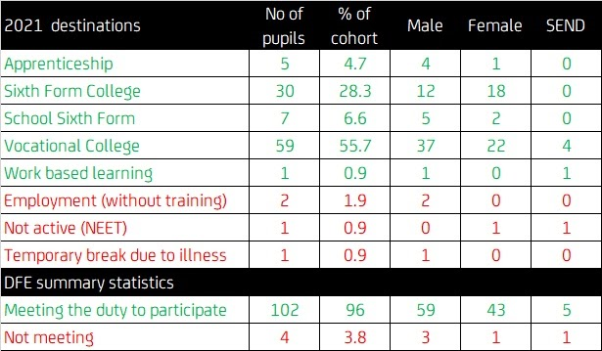

2020 Destination data
Again the vast majority of students were successful in moving to college, training or employment but some were still looking for work when the data was compiled.
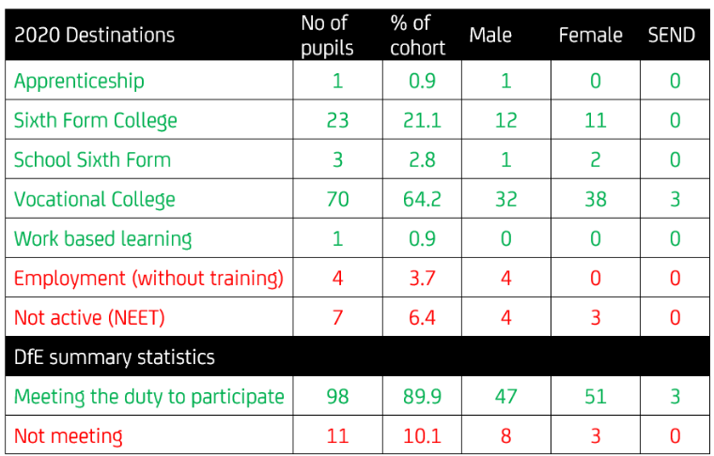

2019 Destination data
The majority of leavers were economically active on the data collection date, although some were still looking for work.
