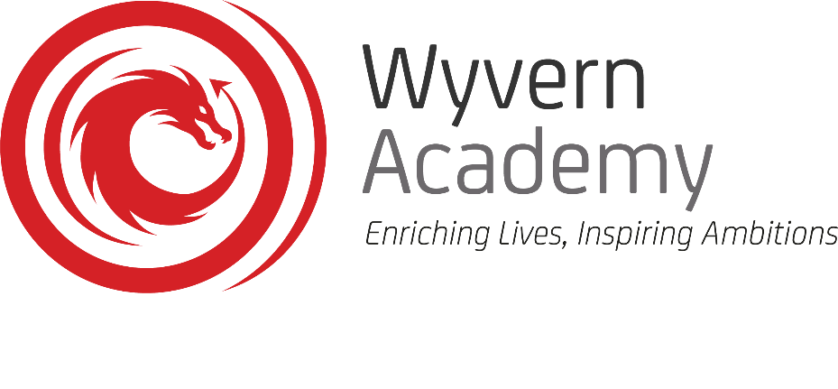

Excellence in all that we do

Headteacher: Mr O Inglis Eggleston View, Darlington, DL3 9SH Tel: 01325 351 377 www.wyvernacademy.org

28th September 2022

Dear Parent/Carer,

I would like to take this opportunity to invite you to our Welcome to Key Stage Four event which will be hosted in school on Thursday 6th October 2022 between 18:00 and 19:00. Students are advised to attend the presentation alongside parents and carers, however, uniform will not be required.

This event has been organised in advance of the first formal set of assessments in years 10 and 11 and will allow us to look at the reality of the public exam system; how best to support pupils with exam anxiety; what can be done at home to support KS4 success and how to support pupils in developing a revision timetable.

Wyvern Academy students achieved strong results in summer 2022, with outcomes demonstrating a significant increase on those achieved since 2019. This exam success was achieved, in part, as a result of strong partnerships established between home and school. We strongly advise parents and carers to attend the presentation to keep up to date with the key messages given. We value the backing of parents in supporting students to achieve and exceed their targeted grades through a close working relationship in the year/s ahead.

If you have any queries or concerns, please do not hesitate to contact me.

Yours sincerely

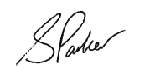
Mr S Parker
Deputy Headteacher

Excellence in all that we do

